**QUESTIONS (MODULE 3)**

1. *An electron has a speed of 600 m/sec, with an accuracy of 0.001 %. Find the uncertainty of the position of the electron.*

**Ans.:** The uncertainty in velocity (Δv) = (0.001/100)×600 m/s = 6×10-3 m/s.

The corresponding uncertainty in momentum (Δp) = mΔv = (9.1×10-31 kg) × (6×10-3 m/s)

= 54×10-34 kg-m/s.

The uncertainty in position (Δx) $≈$ ℏ/2Δp = 1.054×10-34 J-s/(2×54×10-34 kg-m/s)

= 9.7×10-3 m.

1. *A 10 g particle moves with a speed of 20 m/s. If, its position is determined with an accuracy of 1 mm, find the uncertainty in its linear momentum. What fraction of the linear momentum is this uncertainty?*

**Ans.**: Uncertainty in position (Δx) = 1 mm = 10-3 m

Uncertainty in momentum (Δp) $≈$ ℏ/2Δx = 1.054×10-34 J-s / 2×10-3 m = 0.527×10-31 kg-m/s

The fraction of the linear momentum uncertainty is = Δp/p =

= 2.76×10-31

1. *The average life time of a nuclear state is 9.97×10-21 s. Find the uncertainty in the energy and frequency of the emitted photon.*

Ans.: From the Uncertainty relation (energy-time), we have ΔE ≥ ℏ/2Δt = 0.5×10-14 J; (ℏ = h/2π = 1.054×10-34 J-s)

Since, E = hν, we have Δν = ΔE/h = (0.5×10-14 J)/(6.62× 10-34 J-s) = 7.55×1018 Hz

1. *X-rays of wavelength 1.0 Å are scattered from a carbon block. Find the wavelength of the scattered beam in a direction making 600 with incident beam. How much kinetic energy is imparted to the recoiling electron?*

Hint: Find λ’ = λ + λc (1-cosϕ), here λ = 1 Å and ϕ = 600

K.E. imparted to the recoiled electron can be found by, hν – hν’ = $\frac{hc}{λ}- \frac{hc}{λ’}$ = $\frac{hc(Δλ)}{λλ’}$

Where Δλ = λ’ – λ

here, h = 6.62× 10-34 J-s and c = 3×108 m/s

1. *Find the maximum velocity of an electron emitted from a photocell having a Cesium emitting surface if light of wavelength 500 nm is incident on it. The work function of Cesium is 1.9 eV.*

Ans.: The work function W0 = hν0, where ν0 is known as the threshold frequency = 1.9 eV

= 3×10-19 J.

Frequency of light (ν) = c/λ = (3×108 m/s)/(500×10-9 m) = 6×1014 Hz

Energy of the incident photon = hν = 3.97×10-19 J

As per Einstein’s Photoelectric Relation;

Maximum K.E = hν - hν0 = 0.97×10-19 J

(1/2) mv2max = 0.97×10-19 J

vmax = 0.463×106 m/s (here m = 9.1×10-31 kg = mass of an electron)

**6.** *Light of wavelength 3500 Å is incident on two metals A and B. Which metal will yield more photoelectrons if their work functions are 5 eV and 2 eV respectively?*

a) A

b) B

c) A & B

d) C

Answer: **b**

Explanation: Here, λ = 3500 Å = 3.5 X 10-7m

Energy of incident photons = hv = hc/λ =

= 3.536 eV

Since the work function of metal A is higher, it will not yield any photoelectrons. Hence, only metal B will yield photoelectrons.

1. *Find the kinetic energy of a photoelectron emitted on shining a light of wavelength*

*6.2 × 10-6 m on a metal surface of work function 0.1 eV.*

Explanation: Kinetic Energy of photoelectrons = hv – Φ0

= (hc/λ)– Φ0

Here, λ = 6.2 × 10-6 m

Φ0 = 0.1 eV = 1.6 × 10-20J

Kmax = 3.2 × 10-20J – 1.6 × 10-20J

= 1.6 × 10-20J =

= 0.1 eV.

1. *From the figure, what’s the relation between T1, T2, and T3?*

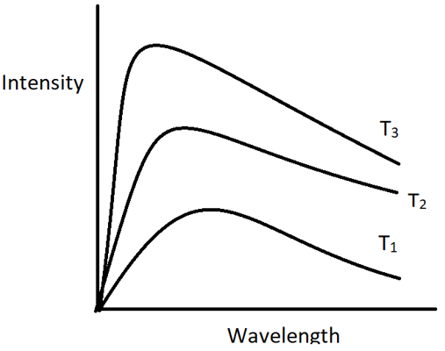

a) T1 > T2 > T3

b) T3 > T2 > T2

c) T3 > T1 > T2

d) T2 > T1 > T3

**Answer: b**

**Explanation:** We already know, as the temperature of the body is higher, the intensity of the black body radiations would be higher. Thus, from the graph, the radiations with temperature T3 has the highest intensity followed by the one with temperature T2 and then T1. Thus, T3> T2 > T1.

1. *Which phenomenon is shown in the figure?*

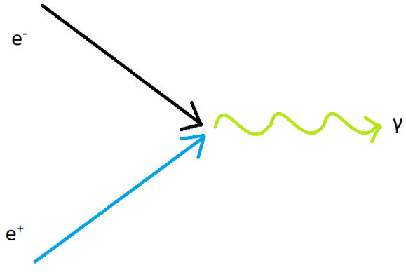

a) Pair Production

b) Photoelectric Effect

c) Compton effect

d) Pair annihilation

**Answer: d**

**Explanation:** In the figure, an electron and a positron annihilate each other and release the equivalent amount of energy. This process is called Pair annihilation. It is just the opposite of pair production.

**QUESTIONS (MODULE 4)**

1. *Which of the following is not a characteristic of wave function?*  
   a) Continuous  
   b) Single valued  
   c) Differentiable  
   d) Physically Significant

**Answer: d**Explanation: The wave function has no physical significance. It merely helps in determining the state of a particle. It is the square of the wave function that has a physical significance.

1. *For a quantum wave particle, E = _____________*a) ℏ k  
   b) ℏ ω  
   c) ℏ ω/2  
   d) ℏ k/2

**Answer: b**  
Explanation: The Energy of a wave particle is given as ℏ ω while the momentum of the particle is given as ℏ k. These are the desired relation.

1. *The Schrodinger wave equation is _______*a) Linear  
   b) Quadratic  
   c) Differential equation  
   d) Derivable

**Answer: a**  
Explanation: The Schrodinger Wave equation is a linear in the wave function Ψ. It means, that no term has Ψ with a degree greater than 1.

1. *If Ψ1 and Ψ2 are two solutions of Schrodinger Wave equation then which of the following is also a solution?*a) Ψ1/Ψ2  
   b) Ψ1Ψ2  
   c) Ψ2/Ψ1  
   d) Ψ1 + Ψ2

**Answer: d**Explanation: Since Schrodinger equation is linear in Ψ, the addition of two solutions of the equation is also a solution of the same equation.

1. *How is information extracted from a wave function?*  
   a) Expectation value  
   b) Operators  
   c) Differential  
   d) Partial differential

**Answer: a**Explanation: Once Schrodinger equation has been solved for a particle, the resulting wave functions contains all the information about the particle. This information can be extracted from the wave function by calculating its expectation value.

1. *Any restrictions present on the particle’s motion in a Schrodinger Equation would affect the ___________*  
   a) Ψ  
   b) dΨ/dt  
   c) d2Ψ/dx2  
   d) U

**Answer: d**Explanation: Any restrictions present on the particle will affect the potential energy function. Once U is known, Schrodinger equation may be solved for the wave function Ψ.

1. *The probabilities that a system can be in the states represented by eigen functions ψ1, ψ2, ψ3 are ½, 1/3, and 1/6 respectively. Write the wave function for the system. If the energy eigen values for the above states are 4 eV, 6 eV and 9 eV respectively, find the energy expectation value?*

**Ans.:** The coefficients of the eigen function are the square roots of the probabilities. So, the eigen function of the system is;

$$Ψ= \frac{1}{\sqrt{2}}Ψ_{1}+\frac{1}{\sqrt{3}}Ψ_{2}+\frac{1}{\sqrt{6}}Ψ_{3}$$

The energy expectation value is;

< E > = [(4/2) + (6/3) + (9/6)] eV = 5.5 eV

1. *The eigen function ψ of a system is a linear combination of eigen functions ϕ1, ϕ2, ϕ3. What is the probability of the system being in the state given ϕ3?*

Ψ = ϕ1+ϕ2+ϕ3

Probability of the system being in the state given ϕ3 = = 1/6 (only eigen state ϕ3 contributes).

1. *A particle can exist in the states ψ1, ψ2 and ψ3with probabilities1/2, 1/3 and 1/6 respectively. Write the wave function of the particle.*

Ans.: ψ1+ ψ2+ ψ3

1. *Calculate the probability of finding a particle in the region 2 ≤ x ≤4,  if the wave function for the particle is given by ψ(x) = 0.25 e2ix.*

Ans.: Probability of finding a particle in the said region will be;

$$P_{x_{1x_{2}}= \int_{2}^{4}{{\left|Ψ\right|}^{2}dx}}$$

${\left|Ψ\right|}^{2}=Ψ^{*}Ψ$ = (0.25 e-2ix) × (0.25 e2ix) = (0.25)2

Probability = (0.25)2 = 0.0625×(2) = 0.125

1. *The wave function for certain particle is Ψ = A cosx for  -π/2 < x < π/2. Find the normalized wave function for the particle.*

Ans.: The wave function is to be normalized means,

$\iiint{{\left|Ψ\right|}^{2}dτ=1}$; dτ = volume element =dxdydz

Since, the wave function of the particle is in the x-direction, hence the normalized condition will be;

;

= A2 cos2x.

⇒A2

Solve the integration and find the value of **A**. The normalized wave function will be the **magnitude of A.** cosx.

1. *Write the quantum mechanical operatiors for energy and momentum.*

Ans.: see the value in the .ppt

Further discussion (model questions) on the module 4 will be continued...